### Arfan Danial Bin Zainal Abidin, 20284997

### Chau Lindon, 20284682

## Test Data

Reference: Yes – 2 Sometimes – 1 No – 0

Risk level score <= 5, Low Risk level score >=14, High Risk level score >5 but <14, Moderate

|  |  |  |  |  |  |  |  |  |  |
| --- | --- | --- | --- | --- | --- | --- | --- | --- | --- |
|  | Frequent urination | Extreme hunger | Weight loss | Blurred vision | Thirsty | Infection | Body fatigue | Slower sores healing | Result/Risk level |
| Test 1 | 2 | 2 | 2 | 2 | 2 | 2 | 2 | 2 | High |
| Test 2 | 2 | 0 | 2 | 1 | 2 | 1 | 0 | 0 | Moderate |
| Test 3 | 0 | 1 | 0 | 1 | 1 | 0 | 1 | 0 | Low |
| Test 4 | 3  (invalid) | 2 | 1 | 0 | 2 | 0 | 1 | 1 | Re-enter data needed for Q1. |
| Test 5 | 2 | A  (invalid) | 2 | 0 | 1 | 2 | 1 | 2 | Re-enter data needed for Q2. |
| Test 6 | 2 | 2 | 53  (invalid) | 1 | 2 | 1 | 2 | 2 | Re-enter data needed for Q3. |
| Test 7 | 2 | B  (invalid) | 99  (invalid) | 1 | 2 | c  (invalid) | 1 | 0 | Re-enter data needed for Q2. Q3. Q6. |

Test Run 1 (screenshot)

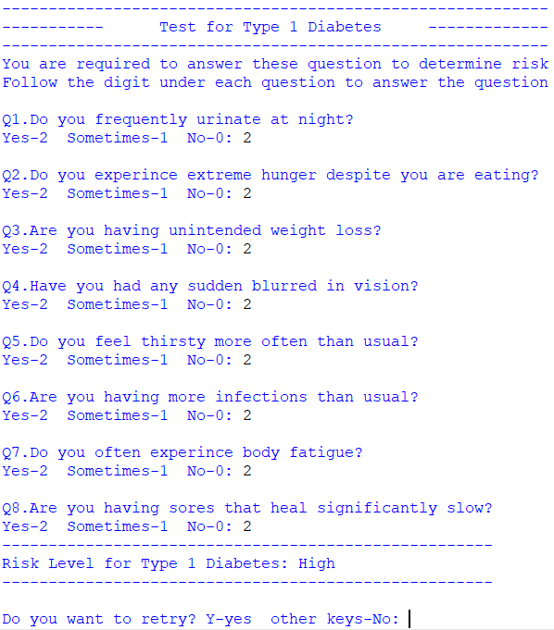

Test Run 2 (screenshot)

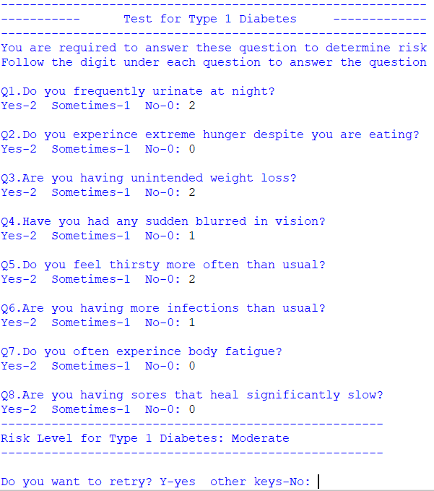

Test Run 3 (screenshot)

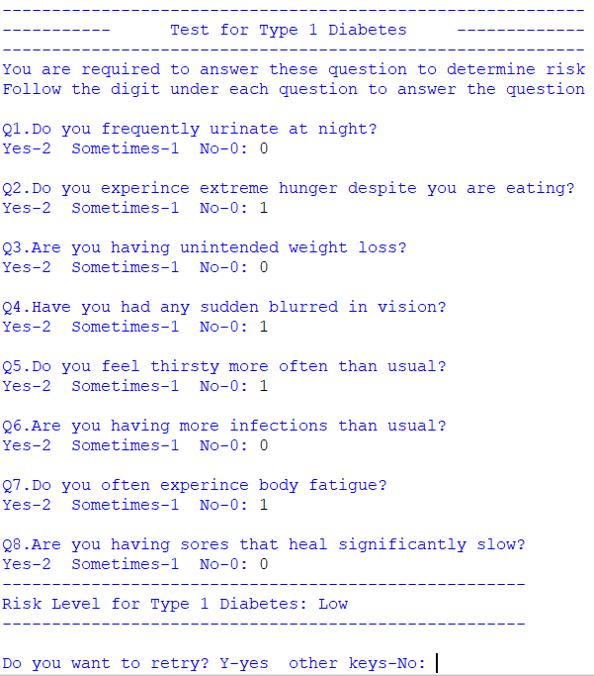

Test Run 4 (screenshot)

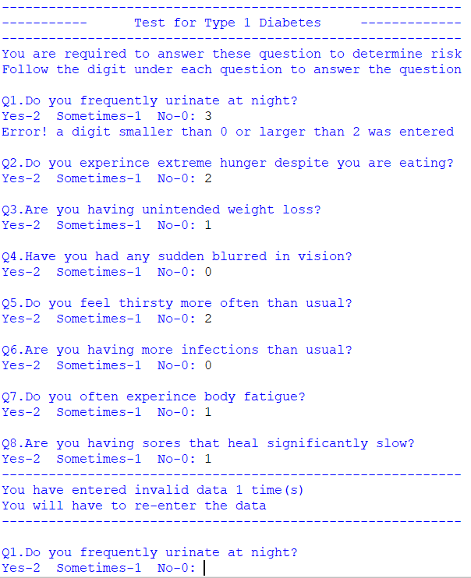

Test Run 5 (screenshot)

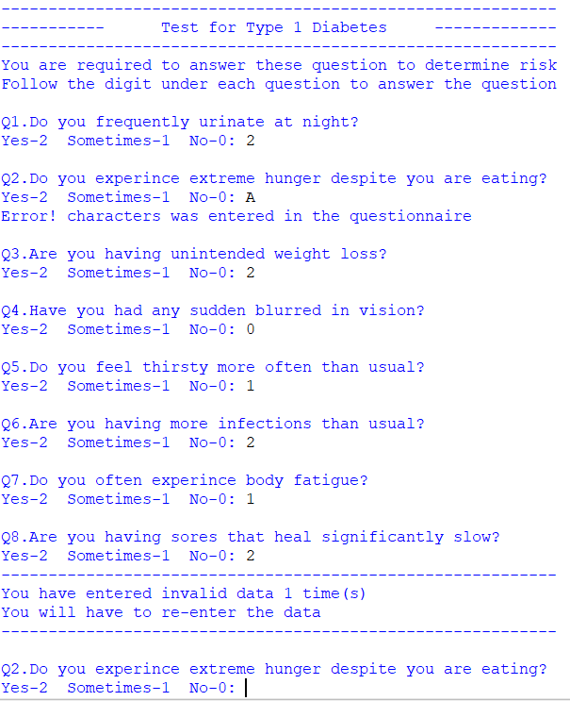

Test Run 6 (screenshot)

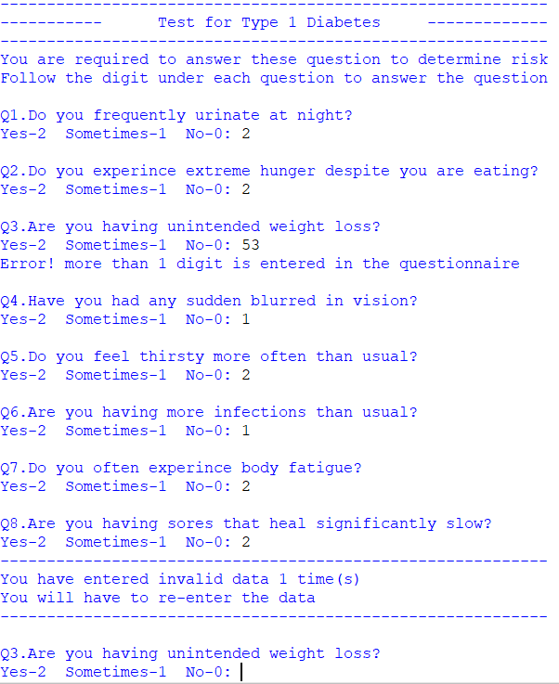

Test Run 7 (screenshot)

## References

<https://www.mayoclinic.org/diseases-conditions/type-1-diabetes/symptoms-causes/syc-20353011>

<https://www.cdc.gov/diabetes/basics/symptoms.html>

<https://www.diabetes.org/diabetes/type-1/symptoms>

## Assumption

* User is given 2 chance to enter valid answer for each question
* If invalid data was entered during the re-enter of data, the program will not ask any further question despite more than 1 question was invalid during first attempt at questionnaire.

(eg. Test Run 7)